|  |
| --- |
| 졸업논문청구논문 |
|  |
| **SeaWiFS 해색 자료를 이용한 동해에서의 chlorophyll-a농도 분석 : LAC 자료와 GAC 자료의 비교**  Analysis of the chlorophyll-a concentration in the Korean East Sea using SeaWiFS ocean color data : comparison between the LAC data and the GAC data |
|  |
| **김 병 현 (**金柄賢**,** **Kim, Byung Hyun)**  15021 |
| **과학영재학교 경기과학고등학교** |
| **2018** |

|  |  |
| --- | --- |
|  | |
| **SeaWiFS 해색 자료를 이용한 동해에서의 chlorophyll-a농도 분석 : LAC 자료와 GAC 자료의 비교**  Analysis of the chlorophyll-a concentration in the Korean East Sea using SeaWiFS ocean color data : comparison between the LAC data and the GAC data | |
| [논문제출 전 체크리스트] |  |
| 1. 이 논문은 내가 직접 연구하고 작성한 것이다. | ■ |
| 2. 인용한 모든 자료(책·논문·인터넷자료 등)의 인용표시를 바르게 하였다. | ■ |
| 3. 인용한 자료의 표현이나 내용을 왜곡하지 않았다. | ■ |
| 4. 정확한 출처제시 없이 다른 사람의 글이나 아이디어를 가져오지 않았다. | ■ |
| 5. 논문 작성 중 도표나 데이터를 조작(위조 혹은 변조)하지 않았다. | ■ |
| 6. 다른 친구와 같은 내용의 논문을 제출하지 않았다. | ■ |

|  |  |  |  |
| --- | --- | --- | --- |
| Analysis of the chlorophyll-a concentration in the Korean East Sea using SeaWiFS ocean color data : comparison between the LAC data and the GAC data | | | |
|  | Advisor : Teacher Park, Kie Hyun | |  |
| by | | | |
| 15021 **Kim, Byung Hyun**  **Gyeonggi Science Highschool for the gifted** | | | |
| A thesis submitted to the Gyeonggi Science Highschool in partial fulfillment of the requirements for the graduation. The study was conducted in accordance with Code of Research Ethics.[1]1) | | | |
|  | | 2017. 6. 19.  **Approved by**  **Teacher Park, Kie Hyun**  **[Thesis Advisor]** | |

|  |  |  |  |  |
| --- | --- | --- | --- | --- |
|  | | | | |
| **SeaWiFS 해색 자료를 이용한 동해에서의 chlorophyll-a농도 분석 : LAC 자료와 GAC 자료의 비교** | | | | |
| 김 병 현 | | | | |
| 위 논문은 과학영재학교 경기과학고등학교 졸업논문으로 졸업논문심사위원회에서 심사 통과하였음. | | | | |
| 2017년 6월 19일 | | |  | |
|  | | | | |
| 심사위원장 | 박 경 애 | (인) | |  |
| 심사위원 | 김 학 성 | (인) | |  |
| 심사위원 | 박 기 현 | (인) | |  |

|  |
| --- |
| Analysis of the chlorophyll-a concentration in the Korean East Sea using SeaWiFS ocean color data : comparison between the LAC data and the GAC data |
|  |
| **Abstract** |
| The seasonal variability chlorophyll-a concentration in the Korean East Sea had been obtained by processing SeaWiFS Local Area Coverage(LAC) and Global Area Coverage(GAC) oceancolor data from January 2003 to December 2006. Both data showed similarities in the tendency showing peaks on spring(April) and fall(November). However, the value of chlorophyll-a concentration was different, the maximum/minimum value of LAC and GAC data each being 1.61 mg/m3 / 0.28 mg/m3, and 1.72 mg/m3 / 0.32 mg/m3. Comparing the pixel histogram of LAC and GAC data showed GAC data had more speckle errors. The pixel analysis of chlorophyll-a concentration data on April, 2003 also showed it is more accurate to use LAC data because of its high resolution. |

|  |
| --- |
| SeaWiFS 해색 자료를 이용한 동해에서의 chlorophyll-a 농도 분석 : LAC 자료와 GAC 자료의 비교 |
|  |
| **초 록** |
| 2003년 1월부터 2006년 12월까지 동해의 chlorophyll-a 농도 계절 변동을 SeaWiFS LAC (Local Area Coverage) 및 GAC (Global Area Coverage) 자료를 가공하여 얻었다. 두 자료 모두 유사한 경향을 보여 봄철(4월)과 가을철(11월)에 농도가 최대로 나타났다. 그러나 LAC와 GAC 데이터의 chlorophyll-a 농도 최대값/최소값은 각각 1.61 mg/m3 / 0.28 mg/m3 과 1.72 mg/m3 / 0.32 mg/m3으로 차이가 나타났다. 더 나아가서 LAC와 GAC 데이터의 픽셀 히스토그램을 비교하여 GAC 데이터에서 스펙클 오류가 더 크게 나타남을 확인하였다. 2003년 4월의 엽록소 농도 데이터의 픽셀 분석 역시 해상도가 높은LAC 데이터를 사용하는 것이 더 정확함을 확인하였다. |

**Contents**

**Abstract**..............................................................................................................i

**초록**....................................................................................................................ii

**Contents**...........................................................................................................iii

**List of Tables**....................................................................................................iv

**List of Figures**...................................................................................................v

**Ⅰ. Introduction**................................................................................................1

**Ⅱ. Methodology**................................................................................................2

**Ⅱ.1. Acquiring SeaWiFS Data**........................................................................................2

**Ⅱ.2. Deriving Chlorophyll-a Concentration Using LAC Data and GAC Data**……...4

**Ⅲ. Results**..........................................................................................................5

**Ⅲ.1. The Annual Variability of Chlorophyll-a Concentration in the Korean East Sea**...........

**Ⅲ.2. The Effect of Spatial Resolution on the Data**.........................................................

**Ⅳ. Discussion**

**References**.........................................................................................................

**감사의 글**.........................................................................................................

**연구활동**...........................................................................................................

**List of Tables**

**Table 1. The mission characteristics of SeaWiFS**....................................................................3

**List of Figures**

**Figure 1.** The annual variability of monthly-mean chlorophyll-a concentration in the Korean East Sea from 2003 to 2006, (a) LAC (b) GAC...................................................................4

**Figure 2.** The annual variability of 8-day-mean chlorophyll-a concentration in the Korean East Sea, (a) LAC (b) GAC. Each 8-day-mean data is average of data from 2003 to 2006....4

**Figure 3.** The monthly-mean chlorophyll-a distribution in the Korean East Sea, LAC. From 2003 to 2006, January to June. The unit of the color bar is mg/m3.........................................4

**Figure 4.** The monthly-mean chlorophyll-a distribution in the Korean East Sea, LAC. From 2003 to 2006, July to December. The unit of the color bar is mg/m3......................................4

**Figure 5.** The monthly-mean chlorophyll-a distribution in the Korean East Sea, GAC. From 2003 to 2006, January to June. The unit of the color bar is mg/m3.........................................4

**Figure 6.** The monthly-mean chlorophyll-a distribution in the Korean East Sea, GAC. From 2003 to 2006, July to December. The unit of the color bar is mg/m3......................................4

**Figure 7.** The monthly chlorophyll-a mean histogram in the Korean East Sea on April, 2003, (a) LAC (b) GAC.................................................................................................................4

**Figure 8.** The monthly chlorophyll-a mean distribution in the Korean East Sea on April, 2003, (a) LAC (b) GAC. Enlarged an area with high concentrations of chlorophyll-a........................................................................................................................................4

**Figure 9.** The monthly chlorophyll-a mean distribution in the Korean East Sea on April, 2003, (a) LAC (b) GAC. Enlarged an area with speckles...........................................................4

.

**Ⅰ. Introduction**

Algae is an important factor in the marine ecosystem. It adds oxygen to water by photosynthesis, and it also determines the water transparency. However, when nutrients are oversupplied, eutrophication occurs causing overgrowth of algae in water. Such phenomenon is called as algal bloom. It blocks sunlight and also consumes lot of oxygen when it dies and decomposes, causing a negative effect on the marine environment. In addition, measuring the amount of algae in the water is crucial.

Ocean color remote sensing allows us to indirectly measure various matters in the ocean. It collects several bands of reflected light from the ocean, which can be calculated to amount of matters using developed algorithms. The data we obtain from such methods is called ocean color data. Ocean color data is important in understanding the temporal and spatial distribution of algae. (김현철, 2006)

Chlorophyll-a concentration can be calculated using ocean color remote sensing. Since chlorophyll-a is a pigment that is required for photosynthesis, it is also found in algae. Additionally, chlorophyll-a concentration is used as a determinant for the amount of algae in ocean. (O’Reilly et al., 1998)

There have been several studies about chlorophyll-a concentration in the Korean East Sea, using ocean color remote sensing. Spring bloom and fall bloom were observed, showing a seasonal pattern. The chlorophyll-a concentration was also found to be related with wind, sea surface temperature, and many other variables of the ocean. (Yamada, K., Ishizaka, J., Yoo, S., Kim, H. C., & Chiba, S., 2004) SeaWiFS(Sea-Viewing Wide Field-of-View Sensor) satellite is often used for studying the chlorophyll-a concentration in the Korean East Sea. It was found to have small areas with abnormally high concentration of chlorophyll-a compared to the areas nearby, which is called speckles. There had been studies to correct this error. (Chae, H. J., & Park, K., 2009; Hu, C., Carder, K. L., & Muller-Karger, F. E., 2001)

SeaWiFS creates two types of level 1 data with different spatial resolutions, Local-Area Coverage(LAC) data and Global-Area Coverage(GAC) data. Level-1 data is a data that had gone through radiometric and geometric calibration. LAC is created with full-resolution(1.1km) for local area while GAC is created with low resolution(4.5km) for a global area. They both use the OC4 algorithm and the color index algorithm to be converted to level-2 chlorophyll-a concentration data. Level-2 data is a data of geophysical variables processed from level-1 data.

Although many scientists used SeaWiFS LAC data and GAC data for research, they did not found which is more suitable. There is also no proof that applying same algorithms will give both accurate results.

The goal of this research are the followings. First, observing the chlorophyll-a concentration variability in the Korean East Sea from 2003 to 2006 using SeaWiFS ocean color data. Second, comparing the chlorophyll-a concentration data of LAC and GAC to find the effect of spatial resolution.

**Ⅱ.** **Methodology**

**Ⅱ.1.** **Acquiring SeaWiFS data**

This research used SeaWiFS ocean color data to derive chlorophyll-a concentration since SeaWiFS is a satellite that was created to collect global ocean biological data. Moreover, SeaWiFS creates data with two different resolutions that can be compared. However, research on recent years is not possible since SeaWiFS had been activating from September 1997 to December 2010.

Table 1. The mission characteristics of SeaWiFS

|  |  |
| --- | --- |
| Orbit Type | Sun Synchronous at 705 km |
| Equator Crossing | Noon +20 min, descending |
| Orbital Period | 99 minutes |
| Swath Width | 2,801 km LAC/HRPT (58.3 degrees) |
| Swath Width | 1,502 km GAC (45 degrees) |
| Spatial Resolution | 1.1 km LAC, 4.5 km GAC |
| Real-Time Data Rate | 665 kbps |
| Revisit Time | 1 day |
| Digitization | 10 bits |
| Band | |  |  |  |  | | --- | --- | --- | --- | | Band | Wavelength | Band | Wavelength | | 1 | 402-422 nm | 5 | 545-565 nm | | 2 | 433-453 nm | 6 | 660-680 nm | | 3 | 480-500 nm | 7 | 745-785 nm | | 4 | 500-520 nm | 8 | 845-885 nm | |

The SeaWiFS Level 2 data of chlorophyll-a was downloaded from NASA Ocean Color Web. Processing Level 1 data to Level 2 data was done by NASA, using NASA SeaDAS program. NASA SeaDAS uses two algorithms to create chlorophyll-a concentration data from the Level 1 data of remote sensing reflectance(Rrs); these algorithms are the OCx band ratio algorithm and the color index(CI) algorithm of Hu.

The OCx band ratio algorithm use the ratio of two bands in a fourth-order polynomial equation in a relation with chlorophyll-a It can be expressed as the following equation.

$$\log_{10}\left(chlor_a\right)=a_{0}+ \sum_{i=1}^{4}{a_{i}\log_{10}{{\left(\frac{R_{rs}(λ_{blue})}{R_{rs}(λ_{green})}\right)}^{i}}}$$

The coefficients $a_{0}\sim a_{4}$ are values for each sensor acquired from experiments. The OCx algorithm described in O’Reilly et al.(1998) was proved to be accurate.

The CI algorithm uses three bands and can be expressed as the following equation.

The $λ_{blue}, λ_{green}{,λ}_{red}$ are wavelengths closest to 443nm, 555nm and 670nm, different for each sensor. According to Hu, C., Lee, Z., & Franz, B. (2012), for the lower concentration of chlorophyll-a (less than 0.25 mg/m3), it is more accurate to use CI algorithm. The NASA SeaDAS program uses CI algorithm for chlorophyll retrievals below 0.15 mg/m3, and OCx band ratio algorithm for retrievals above 0.2 mg/m3. For the concentration between 0.15 mg/m3 and 0.2 mg/m3, it blends both algorithm.

The area of interest was chosen as 32.31 $°N \sim$ 45.00 $°$ N, 126.74 $°E$ ~135.00 $°$ E which covers the whole East Sea near Korea. The Yellow Sea is not covered in this research because it is too shallow for the algorithms to be applied. The dates of the data were chosen from the year 2003 to 2006. This is because from 2007, the number of data files decreases significantly due to the errors generated in the satellite.

**Ⅱ.2.** **Deriving Chlorophyll-a Concentration using LAC data and GAC data**

NASA SeaDAS is used to process the level 2 data of chlorophyll-a to level 3 data of monthly-mean/ 8-day-mean of chlorophyll-a concentration data. Monthly-mean data is created to show the overall tendency, while 8-day-mean data is created to see more specific tendency. Simple average method had been used to create the mean files. This method sum pixel values of chlorophyll-a at the same location and divide it by the number of data that has been compiled. This process also gives latitude longitude value to the pixels, creating a Standard Mapped Image(SMI). Chae, H. J., & Park, K. (2009) used weighted average method to process data. However, according to Park, K. A., Park, J. E., Lee, M. S., & Kang, C. K. (2012), both the weighted average method and the simple average method are suitable for processing SeaWiFS data in East Sea. In addition, we use the more general method which is the simple average method.

Since running each process using SeaDAS is inconvenient, so we automate the process by using python batch processing. This commands SeaDAS to repeat the process. Python can also create png files from the SMI. We use the obtained monthly-mean and 8-day-mean data to find the annual variability of chlorophyll-a concentration.

The effect of spatial resolution on the data was also progressed. The histograms for chlorophyll-a concentration were compared between LAC data and GAC data. Then, the SMI data itself was enlarged to find the difference between them.

**Ⅲ.** **Results**

**Ⅲ.1.** **The Annual Variability of Chlorophyll-a Concentration in the Korean East Sea**

The annual variability of chlorophyll-a concentration in the Korean East Sea from 2003~2006 is shown in Figure 1, Figure 2. Both the LAC data and the GAC data has similar tendency, showing peaks on spring(April) and fall(November). The maximum/minimum value of LAC and GAC data was each 1.61 mg/m3 / 0.28 mg/m3, and 1.72 mg/m3 / 0.32 mg/m3. The difference between the two data was not ignorable. This infer that the effect of spatial resolution on the data has to be considered.

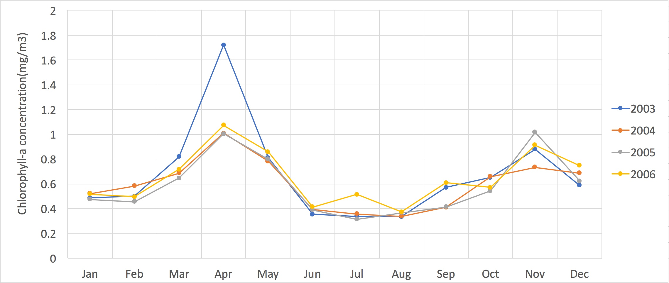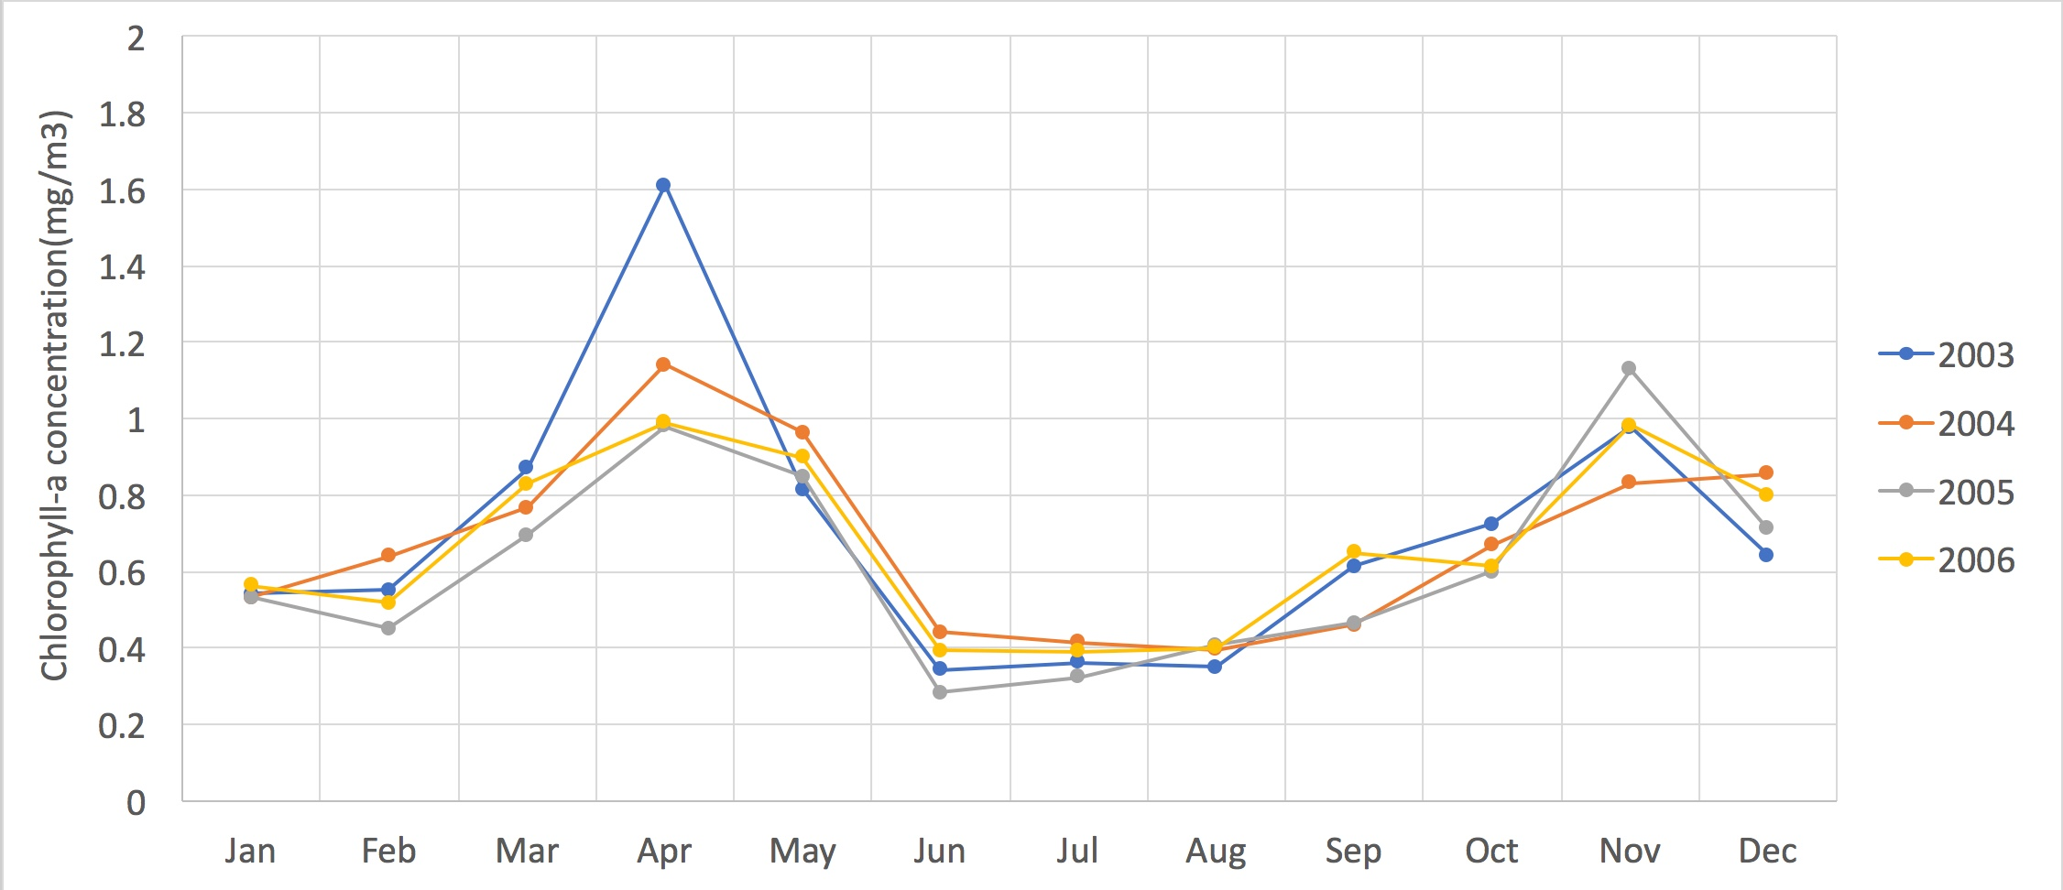

(a)

(b)

Figure 1. The annual variability of monthly-mean chlorophyll-a concentration in the Korean East Sea from 2003 to 2006, (a) LAC (b) GAC.

The annual variability of 8-day-mean chlorophyll-a concentration in the Korean East Sea from 2003 to 2006 is shown in Figure 3, Figure 4. This result allowed more concrete analysis of the data. The spring peak had 1.2 ~ 1.3 mg/m3 of chlorophyll-a concentration and was higher than the fall peak which had the value of 0.9 ~ 1.0 mg/m3. Winter had a higher concentration (0.6 mg/m3) compared to summer (0.4 mg/m3). The chlorophyll-a concentration in the Korean East Sea had clear seasonal differences. Both the LAC data and the GAC data was sufficient to show the seasonal differences. However, even though the 8-day mean data was created using average of 4 years, the time of maximum concentration was different.

Part of the LAC data (2004 46th 8-day-mean, 2005 11th 8-day mean, 2005 31th 8-day mean) had been lost due to satellite failures. The data for these dates were substituted with the average of the adjacent data. This did not have a significant effect on the tendency, so the error was ignorable.

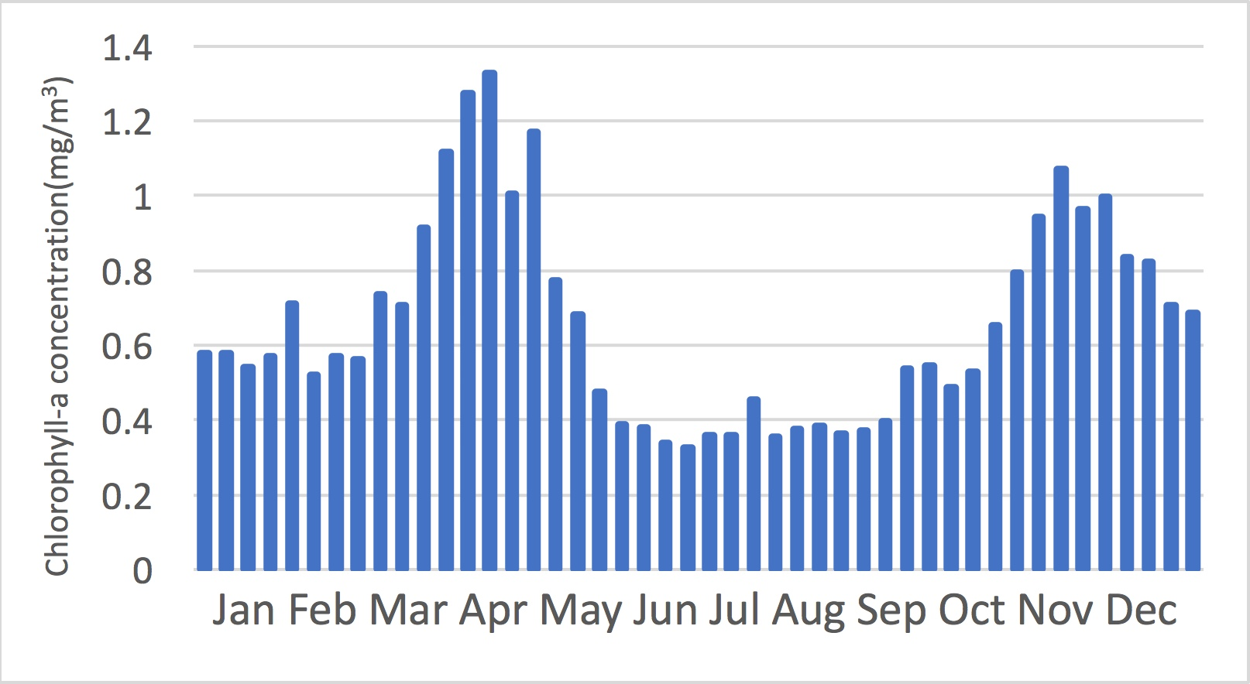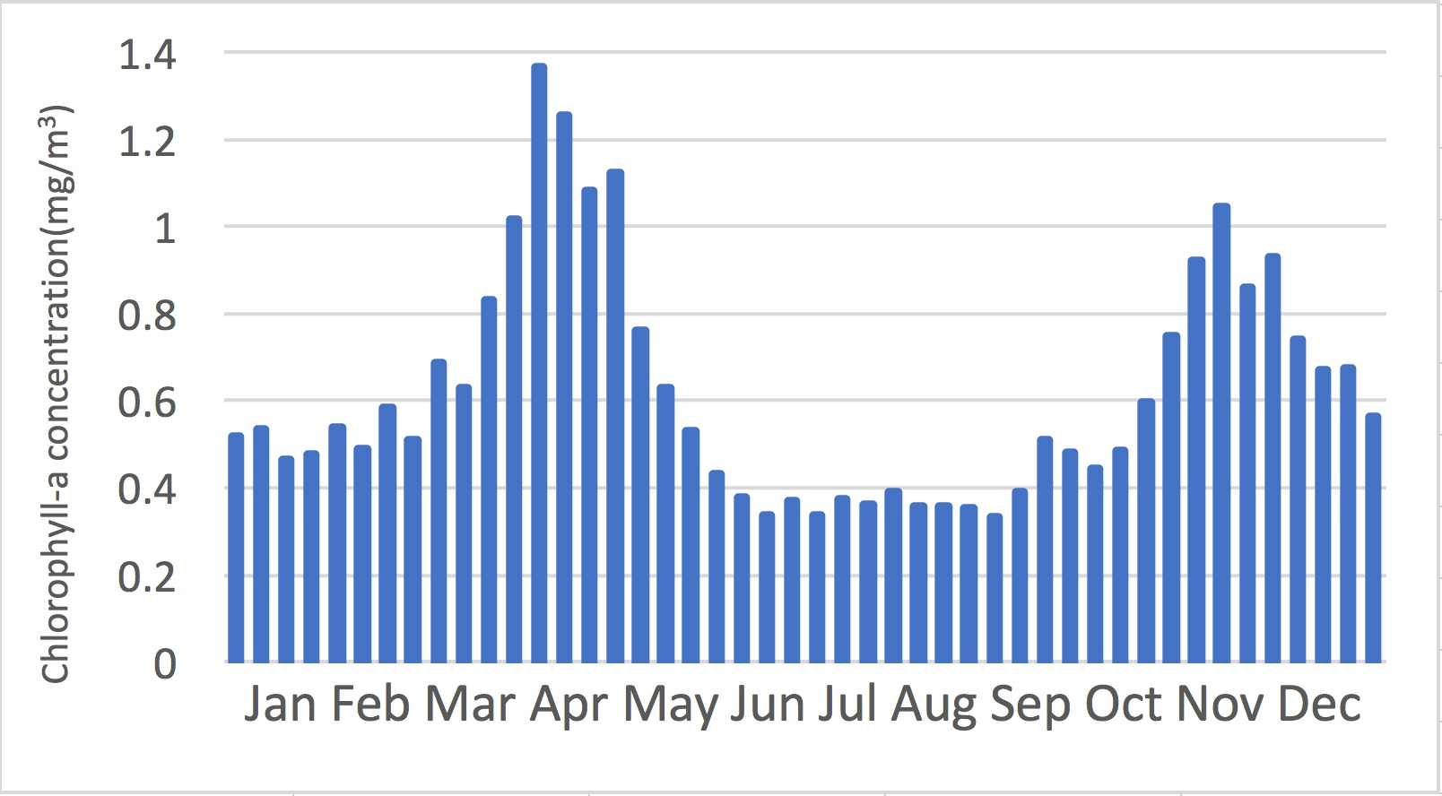

(b)

(a)

Figure 2. The annual variability of 8-day-mean chlorophyll-a concentration in the Korean East Sea, (a) LAC (b) GAC. Each 8-day-mean data is average of data from 2003 to 2006.

The monthly-mean chlorophyll-a concentration of LAC from 2003 to 2006 is shown in Figure 5 and Figure 6. The monthly-mean chlorophyll-a concentration of GAC from 2003 to 2006 is shown in Figure 7 and Figure 8. The grey area is land showing Korea at the west and Japan at the southeast. Red means high concentration than the blue as it can be told from the color bar. Spring (March, April, May) and fall (October, November) show high concentration. The black area is part with no data due to cloud coverage or satellite failures.

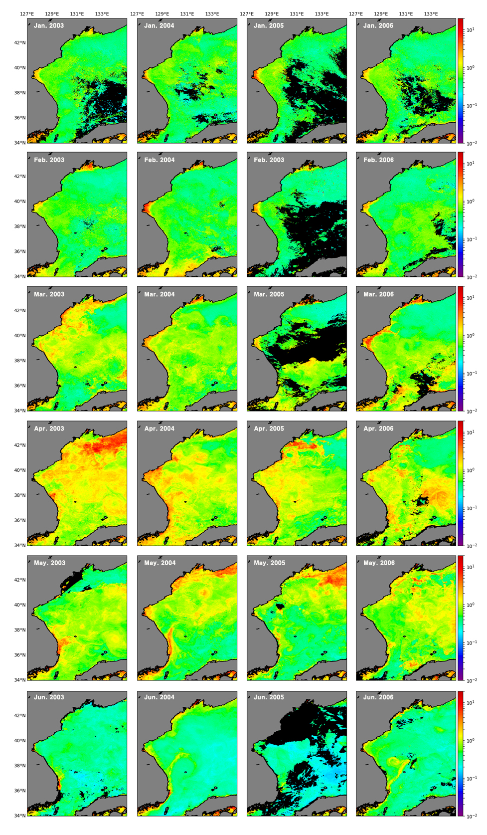

Figure 3. The monthly-mean chlorophyll-a distribution in the Korean East Sea, LAC. From 2003 to 2006, January to June. The unit of the color bar is mg/m3.

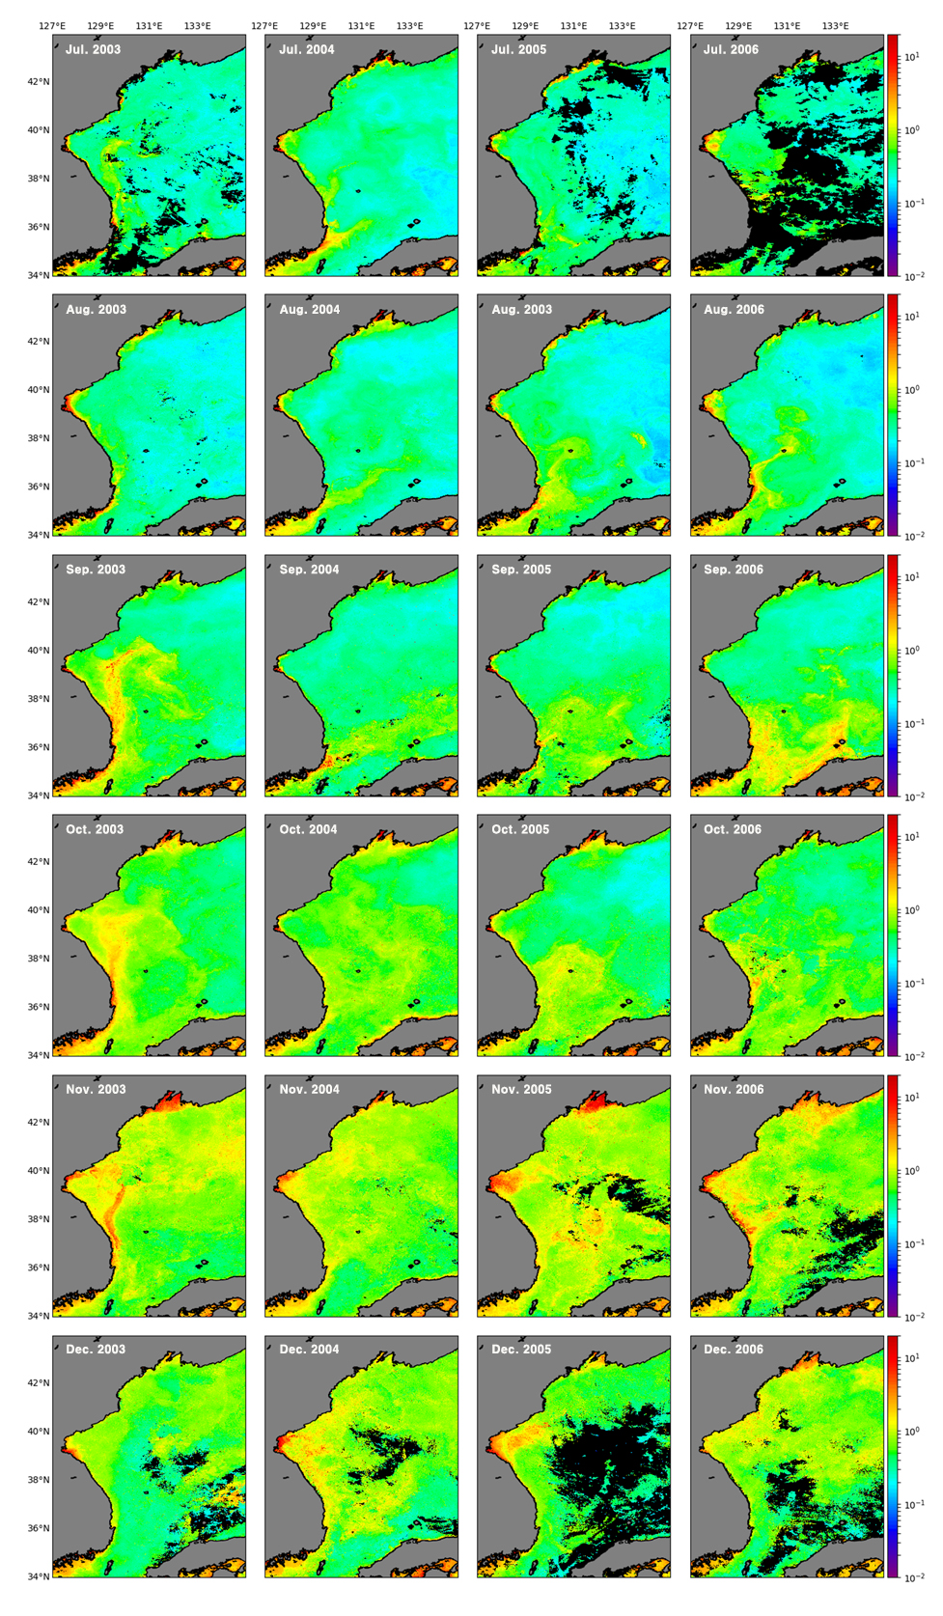

Figure 4. The monthly-mean chlorophyll-a distribution in the Korean East Sea, LAC. From 2003 to 2006, July to December. The unit of the color bar is mg/m3.

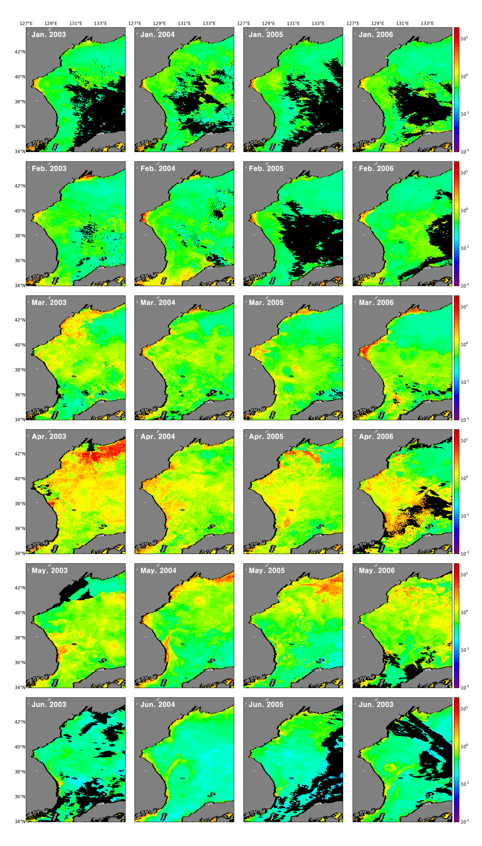

Figure 5. The monthly-mean chlorophyll-a distribution in the Korean East Sea, GAC. From 2003 to 2006, January to June. The unit of the color bar is mg/m3.

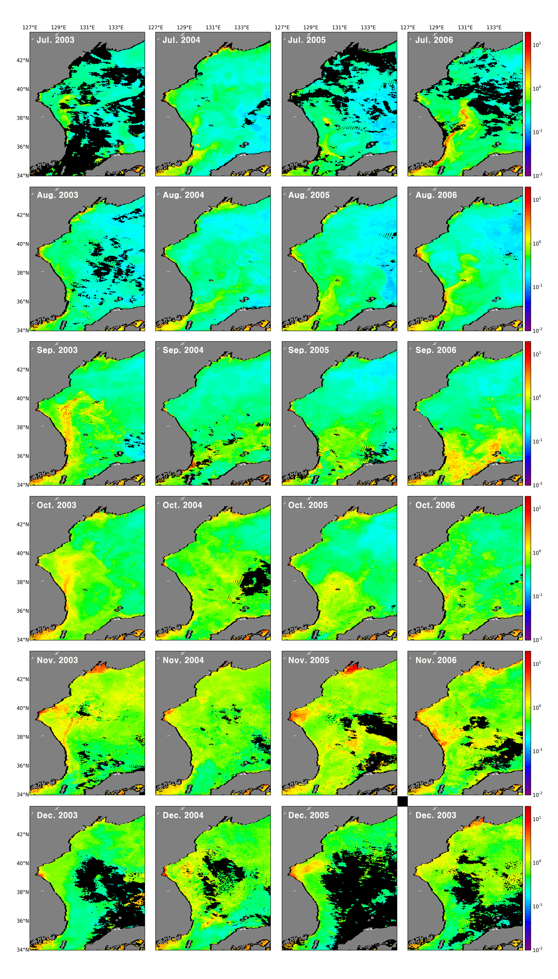

Figure 6. The monthly-mean chlorophyll-a distribution in the Korean East Sea, GAC. From 2003 to 2006, July to December. The unit of the color bar is mg/m3.

**Ⅲ.2.** **The Effect of Spatial Resolution on the Data**

To find the effect of spatial resolution on the data, we compare the histograms of LAC data and the GAC data of April, 2003. We find that the histogram of GAC data shows more discontinuous shape compared to the LAC data in Figure.9. From the fact that a histogram of real data has continuous shape, it can be inferred that using LAC data is more accurate than using GAC data. The histogram of GAC data also shows more pixels with over 10 mg/m3 of chlorophyll-a concentration with sporadic distribution. These pixels are the speckles from previous researches (Chae, H. J., & Park, K., 2009; Hu, C., Carder, K. L., & Muller-Karger, F. E., 2001) also showing that LAC data is more appropriate for studying chlorophyll-a concentration.

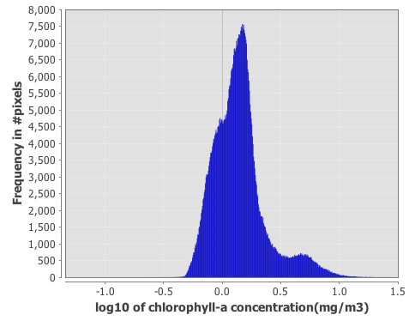 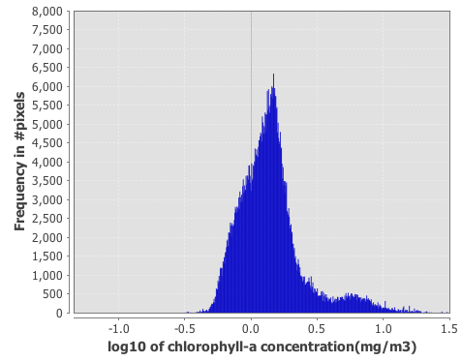

(b)

(a)

Figure 7 The monthly chlorophyll-a mean histogram in the Korean East Sea on April, 2003, (a) LAC (b) GAC.

In Figure 10, part of the data with high chlorophyll-a concentration is enlarged to compare between LAC data and GAC data. LAC data has 6 pixels over 10 mg/m3, while GAC data has more than 100 pixels over 10 mg/m3. Such result occurs since one high-concentration value in GAC data affects a large area compared to LAC because of its low resolution.

In Figure 11, part of the data with speckles is enlarged to compare between LAC data and GAC data. GAC data has a larger size of speckle because it has low resolution. In other words, it has more errors. Even if the speckles of the GAC data has been corrected, it will correct larger area compared to LAC causing a larger gap between the real value. In addition, even with the speckle correction applied using corrected LAC data will be more accurate.

(b)

(a)

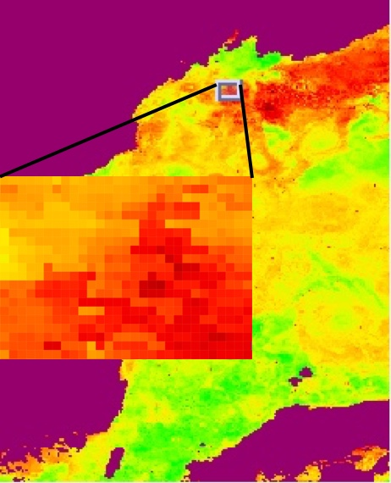 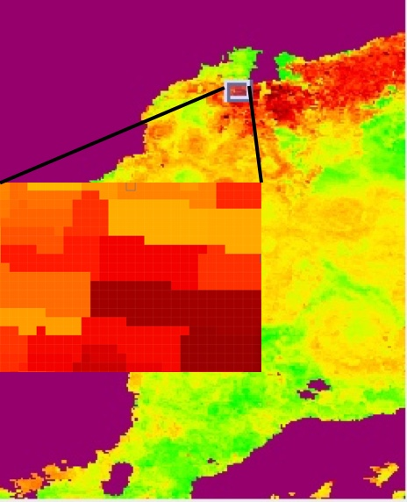

Figure 8. The monthly chlorophyll-a mean distribution in the Korean East Sea on April, 2003, (a) LAC (b) GAC. Enlarged an area with high concentrations of chlorophyll-a.

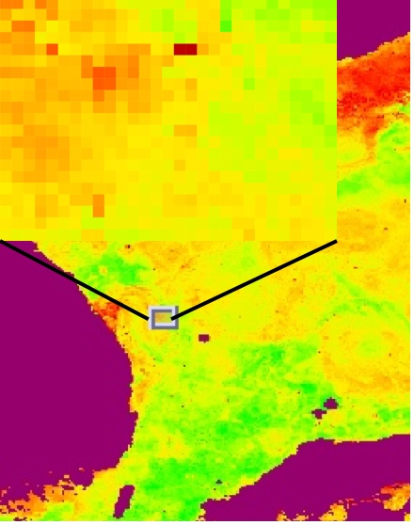 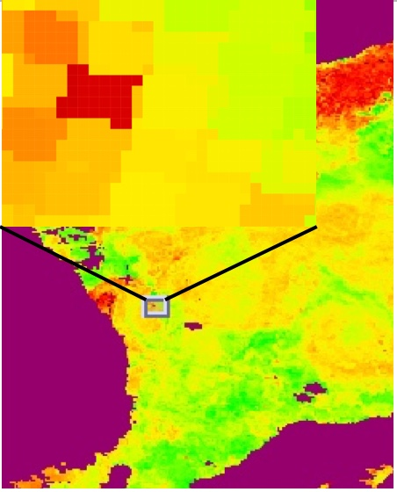

(b)

(a)

Figure 9. The monthly chlorophyll-a mean distribution in the Korean East Sea on April, 2003, (a) LAC (b) GAC. Enlarged an area with speckles.

**Ⅳ.** **Discussion**

Spring(April) and fall(November) each had 1.2 ~ 1.3 mg/m3, 0.9 ~ 1.0 mg/m3 of chlorophyll-a concentrations which was higher than the other seasons showing similarities with the result of Yamada, K., Ishizaka, J., Yoo, S., Kim, H. C., & Chiba, S. (2004). Analysis of annual variability with the temporal resolution increased to 8-day-mean data showed winter (December, January, February) had higher concentration compared to summer (June, July, August), each with the values of 0.6 mg/m3 and 0.4 mg/m3. This conclude that the Korean East Sea shows clear seasonal differences.

In a perspective of spatial resolution, both the LAC data and the GAC data were suitable for research on the chlorophyll-a concentration variability in the Korean East Sea. However, histogram analysis showed that GAC data had more speckles compared to LAC data. The pixel analysis of chlorophyll-a concentration data on April, 2003 also showed that even with the speckle correction it is more accurate to use LAC data because of its high resolution.

The limit of this research is that speckle errors were not corrected causing the concentration values to be higher than the in-situ data. Moreover, the in-situ data of the area of interest was not measured in this research so it could not directly show whether the LAC data or the GAC data is more accurate. Further research will compare the processed data of LAC and GAC with the in-situ data from previous researches.

**References**

[1] Chae, H. J., & Park, K. (2009). Characteristics of Speckle Errors of SeaWiFS Chlorophyll-α Concentration in the Korean East Sea. *Journal of the Korean earth science society*, 30(2), 234-246.

[2] Hu, C., Carder, K. L., & Muller-Karger, F. E. (2001). How precise are SeaWiFS ocean color estimates? Implications of digitization-noise errors. *Remote Sensing of Environment*, 76(2), 239-249.

[3] Hu, C., Lee, Z., & Franz, B. (2012). Chlorophyll algorithms for oligotrophic oceans: A novel approach based on three‐band reflectance difference. *Journal of Geophysical Research: Oceans*, 117(C1).

[4] O'Reilly, J. E., Maritorena, S., Mitchell, B. G., Siegel, D. A., Carder, K. L., Garver, S. A., ... & McClain, C. (1998). Ocean color chlorophyll algorithms for SeaWiFS. *Journal of Geophysical Research: Oceans*,103(C11), 24937-24953.

[5] Park, K. A., Park, J. E., Lee, M. S., & Kang, C. K. (2012). Comparison of Composite Methods of Satellite Chlorophyll-a Concentration Data in the Korean East Sea*. Korean Journal of Remote Sensing*, 28(6), 635-651.

[6] Yamada, K., Ishizaka, J., Yoo, S., Kim, H. C., & Chiba, S. (2004). Seasonal and interannual variability of sea surface chlorophyll a concentration in the Japan/East Sea (JES). *Progress in oceanography*, 61(2), 193-211.

[7] 김현철. (2006). (A) Study of surface chlorophyll variation in the Korean East Sea using ocean color remote sensing data (Doctoral dissertation, 서울대학교 대학원).

|  |
| --- |
| **감 사 의 글** |
|  |
| 정말 감사합니다. |

|  |
| --- |
| **연 구 활 동** |
|  |
|  |

1. 1) Declaration of Ethical Conduct in Research**:** I, as a graduate student of GSHS, hereby declare that I have not committed any acts that may damage the credibility of my research. These include, but are not limited to: falsification, thesis written by someone else, distortion of research findings or plagiarism. I affirm that my thesis contains honest conclusions based on my own careful research under the guidance of my thesis advisor.